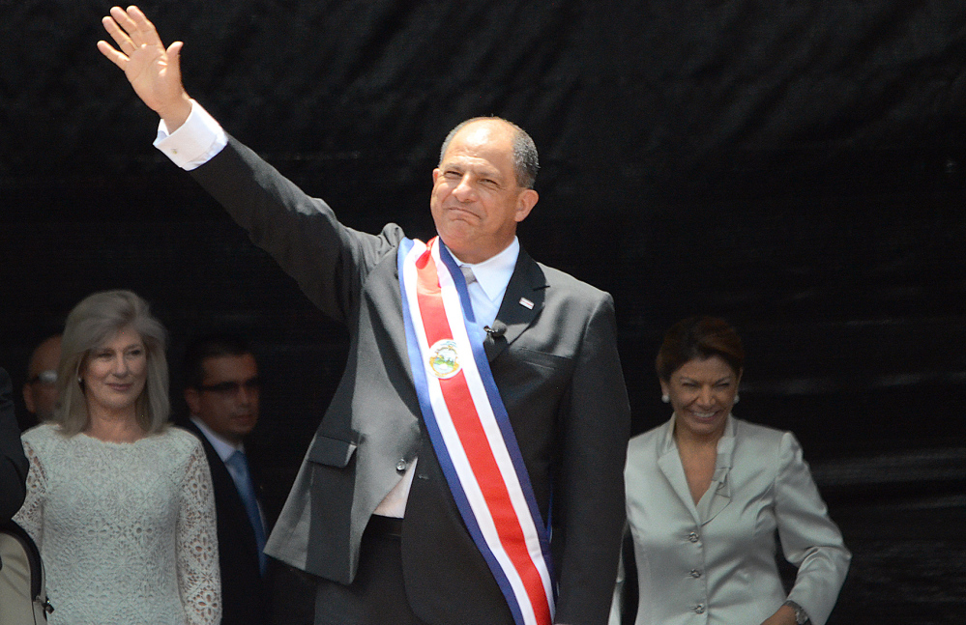  President Luis Guillermo Solís, wearing the tricolor presidential sash of Costa Rica, waves to the crowd at San José's National Stadium on Thursday, May 8, 2014. |  | Government System in Costa Rica  - By: Isabelle Jimenez  - Published: 11/4/14

The Basics of COsta rica’s government system

- Costa Rica is a democratic republic
- They do NOT have a military
- There is a strong system use of checks and balances
- There is a president of the country, who serves a four year term, and selects their own cabinet members.
- There are seven proclaimed provinces in the country; San Jose is the capital
- The Costa Rica legal system is based on the Spanish Civil Code; a judicial review of legislative acts in the Supreme Court.
- There is an independent Supreme Electoral Tribunal.
- Just like the United States, the Costa Rica government is divided into three branches: judicial, legislative, and executive.
- The judicial branch is the Supreme Court of Justice, it has 22 judges who serve 8 year terms.
- The legislative branch is the Unicameral National Assembly which has 57 seats that are elected by popular vote and serve 4 year terms.
- The executive branch is composed of the president, two vice presidents, and the 20 or more members of the cabinet.
- Responsibilities are solely vested into the president.
The judicial branch plays a crucial role in the country compared to the legislative and executive branch. All courts established by law constitute the judicial branch. In article one of the constitution of Costa Rica: “ The judicial branch shall conduct trials on civil, criminal juvenile criminal, commercial, labor and administrative cases regarding property, constitutional, family, and agrarian matters, as well as others established by law. It shall make final decisions with the help of law enforcement if necessary.” There are three spheres in the judicial branch; jurisdictional, auxiliary, and administrative. There are four chambers.

