Educational Status in Costa Rica
In Costa Rica, the educational system is looked at as one of the most important things that a person can have. In 1869, the country made education both free and mandatory for every one of the citizens. In doing this, the country’s educational system has grown to include more than four thousand schools. In the past thirty years, Costa Rica has invested about 30% of the national budget in primary and secondary education. The literacy rate of residents ages 15 and older is at a whopping 95%. (“Costa Rica’s Education System,” 2011) College tuition rates are about 50% lower when compared to U.S. in-state tuition rates, and every university, both private and public, guarantee a quality education for a more financially secure future. (InterNations, 2012)
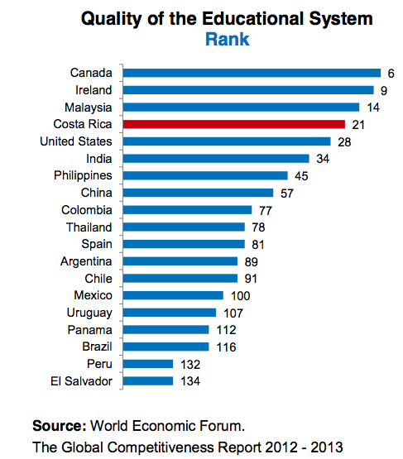

This image above shows the ranking of Costa Rica educationally, compared to many other countries around the world, and they rank within the top 5, which is an incredible accomplishment, especially for a country that is so small, to flourish so much in matters of academics.
There are three cycles in the educational system in the country, and they are spilt by age; up to age 7 is cycle one, which would be considered pre-education, ages 7-12 is primary education, and 12-18 is secondary education, which then leads to further education such as college. (Wikipedia, 2014) The secondary Education cycle is divided in two of its’ own cycles of three years. The first cycle is dedicated to general education. The second cycle, while keeping a focus on a core curriculum, utilizes specialization. Specializations can be academic or technical. (Wikipedia, 2014)
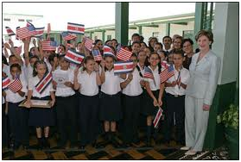

Schools in Costa Rica require the students to wear a uniform, which makes it so that everyone can fit in, as well as focus on the education they are receiving rather that what one another is wearing. (Costa Rica Law, 2013).

References
Costa Rica Law. (2013). Educational System. Retrieved from http://www.costaricalaw.com/Educational-System/
Costa Rica's Education System. (2011, November 2). Retrieved from http://costarica.com/relocation/costa-ricas-education-system/
InterNations. (2012). Education in Costa Rica | InterNations.org. Retrieved from http://www.internations.org/costa-rica-expats/guide/living-in-costa-rica-15466/education-in-costa-rica-2
Wikipedia. (2014, October 28). Education in Costa Rica - Wikipedia, the free encyclopedia. Retrieved November 4, 2014, from http://en.wikipedia.org/wiki/Education_in_Costa_Rica#U

